May 2007 PAUSE Review
May 1, 2, or 3rd, 1-3 PM EDT,
RSVP with preferred date to Matthew Rohrbach (617) 494-3452, PAUSEsecretariat@volpe.dot.gov

Read-ahead Material

Dear PAUSE Members:
Thank you for your interest in participating in one of the PAUSE Review web conferences scheduled for May 1-3, 2007.

The review will feature a series of activities that the ITS Joint Program Assessment Program is considering while developing a roadmap of activities for the coming years. This document includes brief one to two-page synopses of each of these activities.
During the call we will ask you to provide a rating of the importance of each activities in terms of its importance to the ITS decision-maker, using the scale below. We will also be asking you to rank order the importance of the activities.

Rating Scale:
0 – Not Needed
1 – Nice to have
2 – Important
3 – Critical

This read-ahead provides you with a short overview of each topic to be discussed at the phone call. We will spend more time on the call on some topics than others, but this need not influence your ratings of the importance of the activities. There will be time provided to discuss each and we will gladly answer any questions you may have regarding them.

Use this read-ahead packet as a quick overview of the topics, and to take notes as the call progresses on your ratings and rankings for the proposed activities.
Thanks in advance for your participation; we look forward to talking with you in early May.

Sincerely,

The PAUSE Organizers

Table of Contents

RSS and E-mail Subscription Services 2
U.S. Version of the U.K. Decision Support Tool 2
Transitioning from Unit Costs Elements to ITS Core Elements 2
Adding Content to Existing Knowledge Resources 2
State of the Practice Knowledge Resource Development 2
ITS Benefits, Costs, Deployment and Lessons Learned: 2008 Update 2
Development of Summary Information on Benefits, Costs, Deployment, and Lessons Learned 2
Leaflet – Congestion Pricing 2
Web-based Inventory of Relevant Forms and Documents 2
Training 2

RSS and E-mail Subscription Services

Continue to offer Really Simple Syndication (RSS) and E-mail Subscription Service (ESS). Continue to refine and enhance RSS and ESS based on user feedback. It is anticipated that the popularity of this type of services will probably grow and, with it, the value of these services will increase when populated with content related to ITS decision-makers' resources.

Both the RSS and Email Subscription Service provide automatic and customized access to selected information concerning ITS. Users subscribed to ESS receive emails with information updates based on a frequency (daily, weekly, or monthly) they select. The value of both services is that they allow users to receive alerts about new information without the need to continuously monitor knowledge resource web sites. In addition, the services can be used to disseminate current information from other sources, including newsletters, and other programs within DOT.

Specific Activities: Continue to offer Really Simple Syndication (RSS) and E-mail Subscription Service (ESS). Continue to refine and enhance RSS and ESS based on user feedback. Additional activities have included automating the RSS item entry creation process, reporting RSS and ESS usage statistics, and creation and delivery of RSS and ESS items that are distributed to all subscribed users.
Deliverables: The deliverables for this activity include:
- Ongoing reporting of RSS and ESS statistics,
- Ongoing RSS and ESS operational support,
- Responding to user comments and feedback, and
- Making potential changes to RSS / ESS based on user feedback.

Outcomes: These ITS information services have the following benefits and outcomes.
- These capabilities allow real time dissemination of updates to the Costs, Benefits, and Lessons Learned Knowledge Resources.
- Users can tailor information they receive from RSS /E-mail Subscription Service to their individual ITS information needs.
- Increased awareness of the knowledge resources among target audience members.

U.S. Version of the U.K. Decision Support Tool

This activity will explore the feasibility and desirability of developing a US version of a decision support tool, originally developed in Britain (http://www.itstoolkit.co.uk/itsdecisiontree.htm). The British ITS Tool Directory a web based application that allows users to relate transportation problems or needs to potential solutions chosen from a set of Intelligent Transportation System ‘tools’. The user enters with a major objective area, such as safety, selects a sub-objective that focuses on one aspect of the objective, such as reducing collisions, and then a mechanism, such as reducing speed. The user is then selects a tool from a set of tools that can achieve the desired mechanism, such as automated speeding detection. The user is then provided information on the selected tool, including a description, key cost drivers, costs, benefits, and other information including factors to consider in deploying the systems. The British system will be analyzed and a similar approach will be prototyped and eventually put on-line, linking application areas from the ITS Taxonomy to goals, objectives, and sub-objectives. The resulting system will be a decision support tool that will provide users with ability to relate potential Intelligent Transportation Systems (ITS) technology solutions to a variety of common transportation needs (e.g., safety, congestion, efficiency, etc…).

Specific Activities:
- Review the UK Decision Support Tool
- Develop US Decision Support Tool requirements
- Design and prototype approach that incorporates key features and functions of UK tool for US application
  - Link application areas from the ITS Taxonomy to goals, objectives, and sub-objectives
  - Develop a user interface employing transportation problem statistics related to goals and objectives to characterize problems to be solved by ITS applications
- Obtain feedback on the prototype from target audience members
- Revise prototype approach as required
- Launch US Decision Support Tool as interface for the Applications Overview

Outcomes:
- User access to knowledge resources will be greatly enhanced for target audiences. Currently, users are required to decide which applications may address their problems before accessing the knowledge resources. With the new user interface, users can start with the problem and let the user interface provide potential solutions.
- Improved understanding by target audience of the range of problems that ITS can address.

Transitioning from Unit Costs Elements to ITS Core Elements

This one-pager read ahead provides an overview of a proposal to transition the ITS unit cost elements structure to one that is based on a smaller, more manageable set of “ITS Core Elements.” Currently, unit cost elements are based on the ITS National Architecture equipment packages. The equipment packages represent equipment items dating back to the 1994-1995 timeframe. The unit cost elements are also based on the equipment in IDAS – ITS Deployment Analysis System, a cost benefit analysis tool. (Updates to the unit cost elements are shared with the IDAS developers and FHWA Office of Planning.) Furthermore, a fair number of unit cost elements are more representative of high-level, less tangible architecture components (e.g., Systems Integration – IDAS IS017, Labor for Probe Information Collection – IDAS TM036). Sources of costs data used to maintain and update the content of the unit cost elements are from planned or actual ITS deployments. The mapping of actual to architecture has long been a challenge in keeping the cost data in the unit cost database current and representative of deployment trends. Many of the unit cost elements could not be updated as cost data gathered did not correspond to the unit cost elements. Over time, the Noblis cost analysis team added a number of unit cost elements to reflect current ITS deployments. These elements have not been incorporated into IDAS.

The proposal is to move the unit costs to a structure that is better aligned with the structure local and state departments of transportation use for planning, cost estimating, deployment, operations, and maintenance. The ITS core elements are envisioned as a much smaller subset of the existing 200 plus unit cost elements (excluding CVISN). By developing the ITS core elements in collaboration with transportation agencies and field staff, and the FHWA Office of Planning, the cost data will be more useful to decision makers and deployers. An added benefit will be increased ability to provide content updates for more cost elements.

In September 2006, unit costs data for commercial vehicle systems were updated with data from the Commercial Vehicle Information Systems and Networks (CVISN) self-evaluation cost collection activity. The former commercial vehicle subsystems are available as downloadable files to users for historical reference. The new CVISN cost data would not be affected by the transition to core elements.

Noblis proposes that the same type of information currently being provided under the ITS unit cost elements will continue for the core elements: capital cost range (low to high), operating & maintenance (O&M) cost range (low to high), life-time (as appropriate), and a brief description. The data will be available on-line and downloadable in Microsoft Excel and Adobe Acrobat formats. As part of the transition to ITS core elements, the latest version of the unit cost elements will be archived and made available as downloadable files to users for historical reference.

By offering a smaller set of core elements, the Noblis cost analysis team will be better able to provide the cost data that ITS deployers and stakeholders need – data that is current and representative of actual deployments.

Adding Content to Existing Knowledge Resources

This activity represents the ongoing "care and feeding" of the Knowledge Resource Web sites to provide new or updated content. Additional detail on these activities for each of the sites is provided below.

Benefits Database - Analysis and documentation of the impacts of ITS from a particular studies or project evaluations, classified by the various taxonomies, and design and implementation of benefits information tools and products for customers to use, such as the benefits knowledge resource web site or a printed publication, like the leaflets.
Specific activities: analyze and document benefits of ITS for the Benefits Knowledge Resource and printed publications (e.g., 2008 "Update" Report, leaflets); re-title benefit summaries and add "advanced search" capability to Benefits KR; prepare Benefit of the month (BOTM) to post on ITS JPO Web site homepage.
Deliverables: new summaries added to the ITS Benefits Database Knowledge Resources and incorporated as appropriate into publications; delivery of monthly "Benefit of the Month" for posting on the ITS JPO Web site homepage.
Outcomes: refinement of existing ITS Benefits Database, addition of new content, increased awareness of the Benefits Database Knowledge Resource.

Costs Database - Analysis and documentation of the costs of ITS from particular studies or project evaluations, classified by the various taxonomies, and design and implementation of costs information tools and products for customers to use, such as the costs knowledge resource web site or a printed publication, like the leaflets.

Specific activities: analyze and document costs of ITS for the Costs Knowledge Resource and printed publications (e.g., 2008 "Update" Report, leaflets); re-title system cost summaries.
Deliverables: updates and enhancements to the ITS Costs Database Knowledge Resource. New content will be incorporated into related publications.
Outcomes: refinement of existing resources, addition of new content, increased awareness of the costs KR.

Lessons Learned Knowledge Resource - Analysis and documentation of experience-based lessons about ITS from individual studies, projects, or sources, classified by the various taxonomies, and design of information tools and products for customers to use, such as the Lessons Learned Knowledge Resource (LLKR) web site or a printed publication like the leaflets. The LLKR captures experiences of stakeholders in their planning, deployment, operations, maintenance, and evaluation of ITS and makes such experience-based knowledge available to all ITS stakeholders so that they can make informed decisions in their own ITS actions.
Specific activities: Gather source documents, extract lessons learned knowledge, write lessons learned articles, post lessons learned articles on the Lessons Learned Web site. Prepare lesson of the month (LOTM) to post on the ITS JPO Web site homepage.
Deliverables: a) 60 to 100 lesson learned articles per year. b) 12 "lesson of the month" (LOTM) articles to post on the ITS JPO Web site Home page.
Outcomes: This activity makes experience-based knowledge available to all ITS stakeholders via a Web site, enabling them to make informed decisions in their own ITS actions.

State of the Practice Knowledge Resource Development

The following charts display results from a set of State of the Practice questions included in the 2006 national survey. The state of the practice concept emerged from work done in a previous PAUSE session, in which members provided sample questions concerning data needs. An analysis of the 170 or so questions provided showed that the questions were almost all centered around ‘how’, such as how other agencies are maintaining ITS equipment, funding operations, maintaining systems, or procuring equipment. Further, the topics for the questions seemed to fit within the nine Lessons Learned categories: management and operations, policy and planning, design and deployment, leadership and partnerships, funding, technical integration, procurement, legal issues, and human resources. We decided to expand the scope of the deployment statistics surveys to include state of the practice, and to use the Lessons Learned categories as the taxonomy for the new database. To test out the concept, we developed nine sample questions, one for each category, for inclusion the 2006 survey. These questions were developed with the help of the PAUSE. We have included interim results from this effort to provide the PAUSE feedback on the status of this effort. These results are as of last February and are not final, but they clearly demonstrate that respondents can go beyond providing counts of deployments to include answers to ‘how’ questions. We are currently working on the 2007 national survey, which will feature the use of state of the practice questions. We hope that some of the PAUSE members will continue to assist in this effort by reviewing draft surveys.

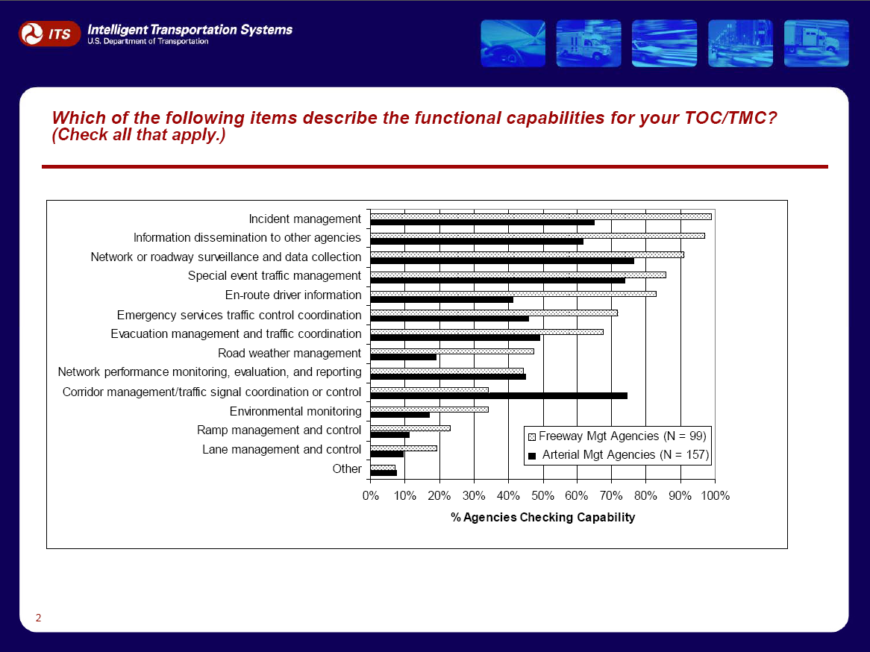
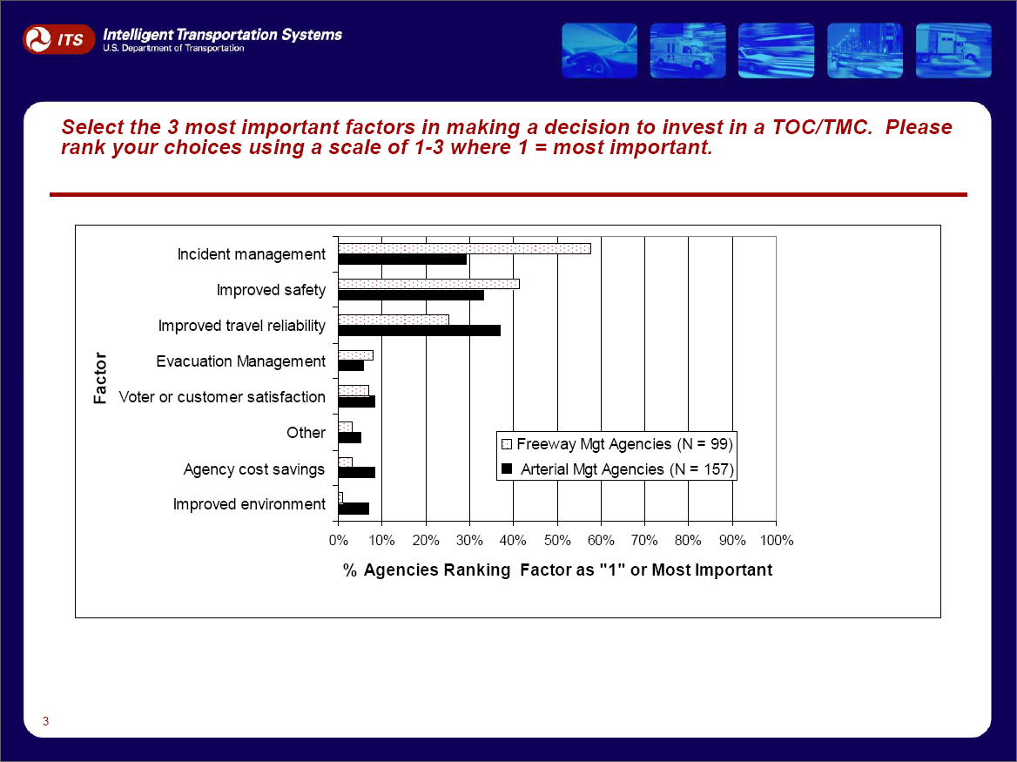

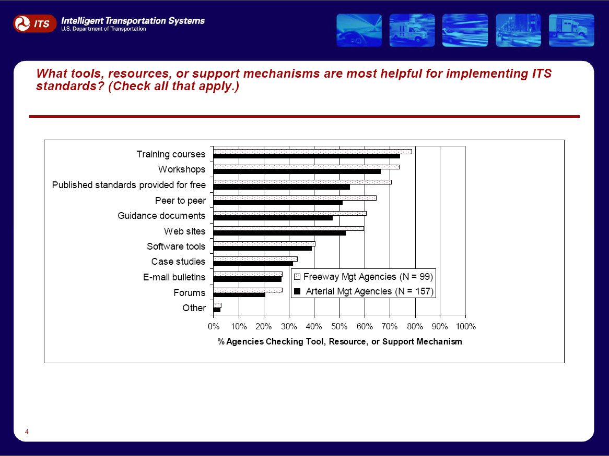
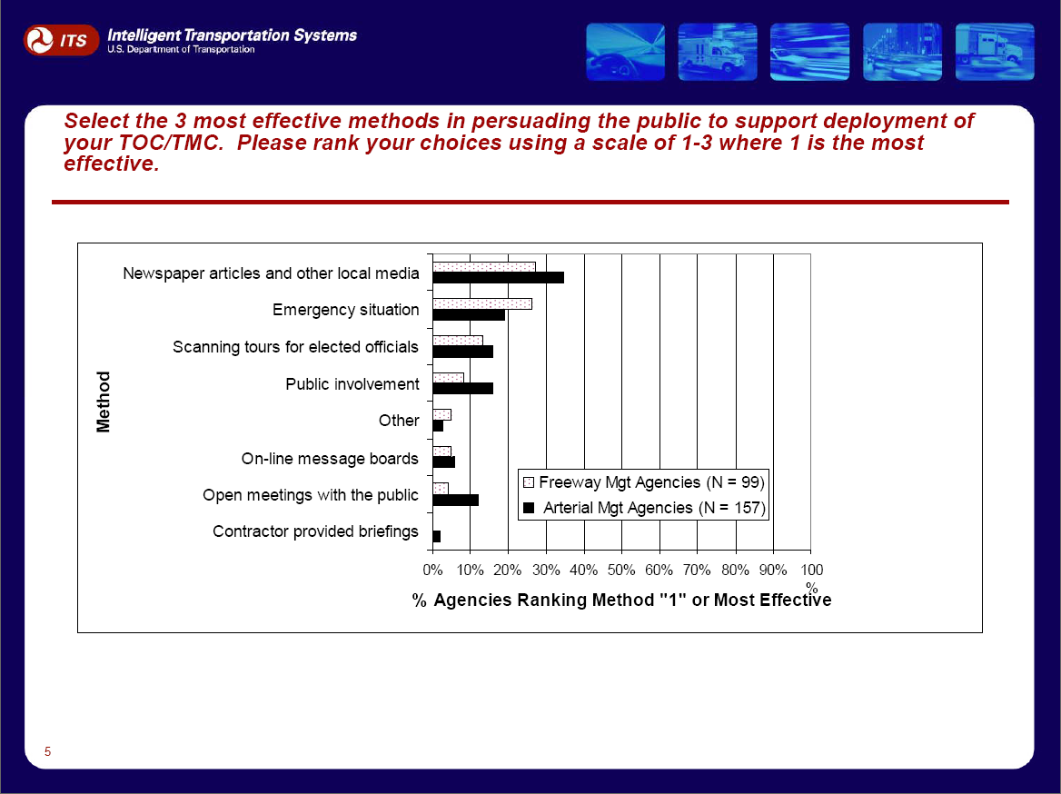

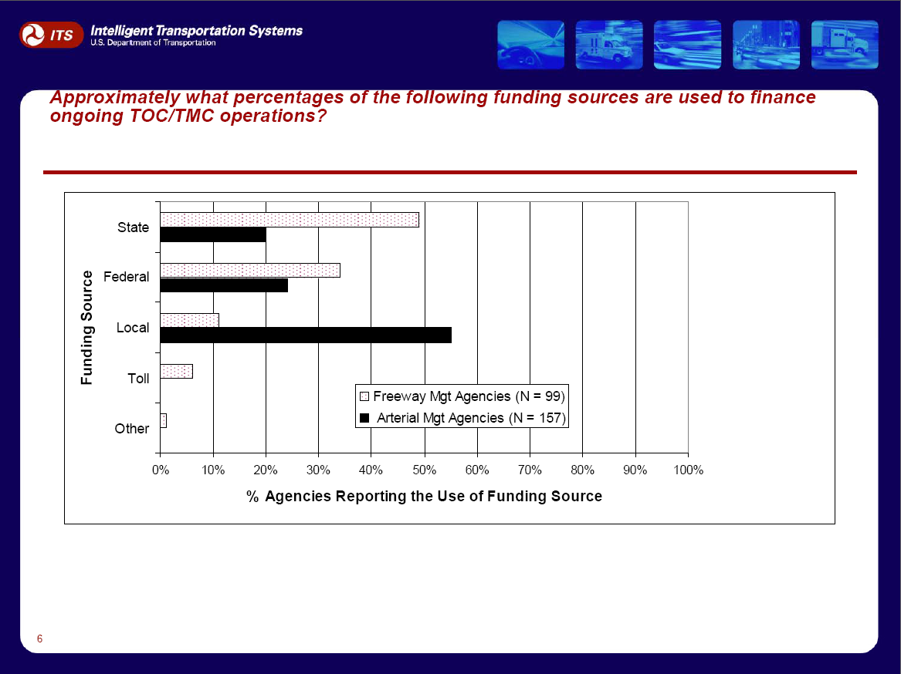
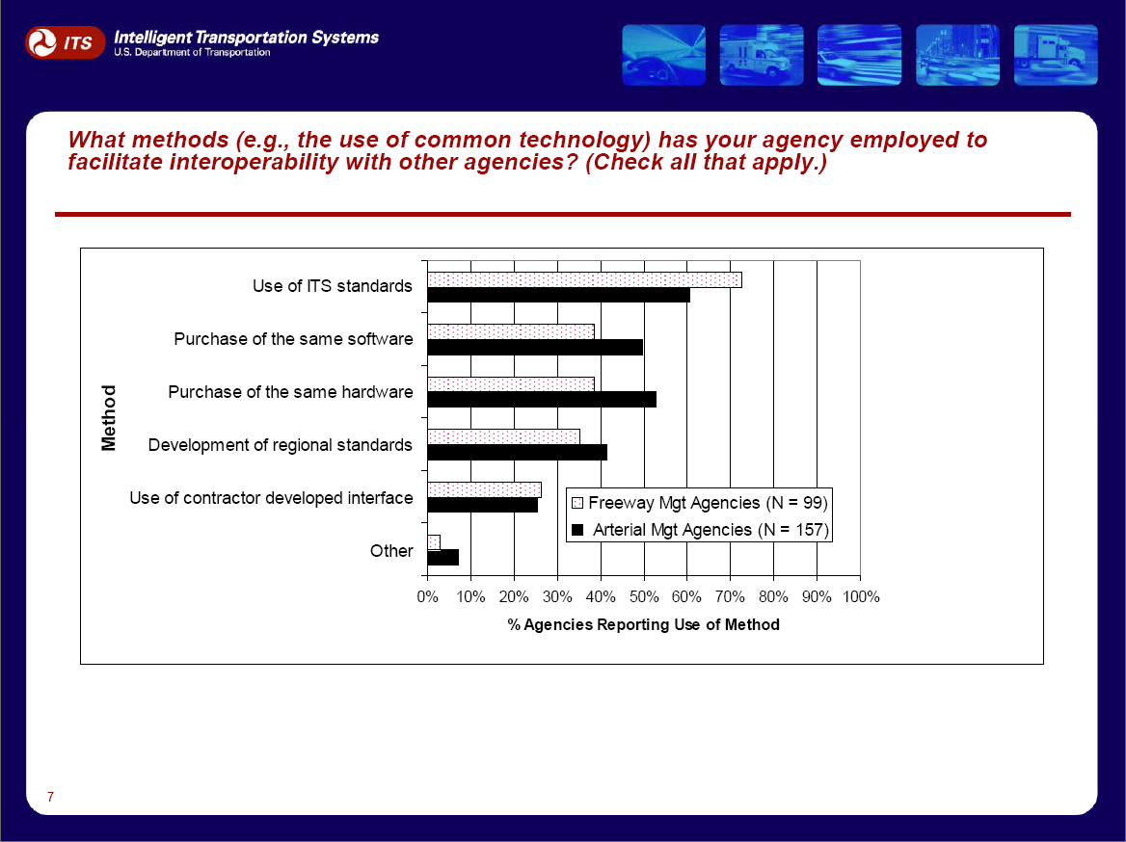

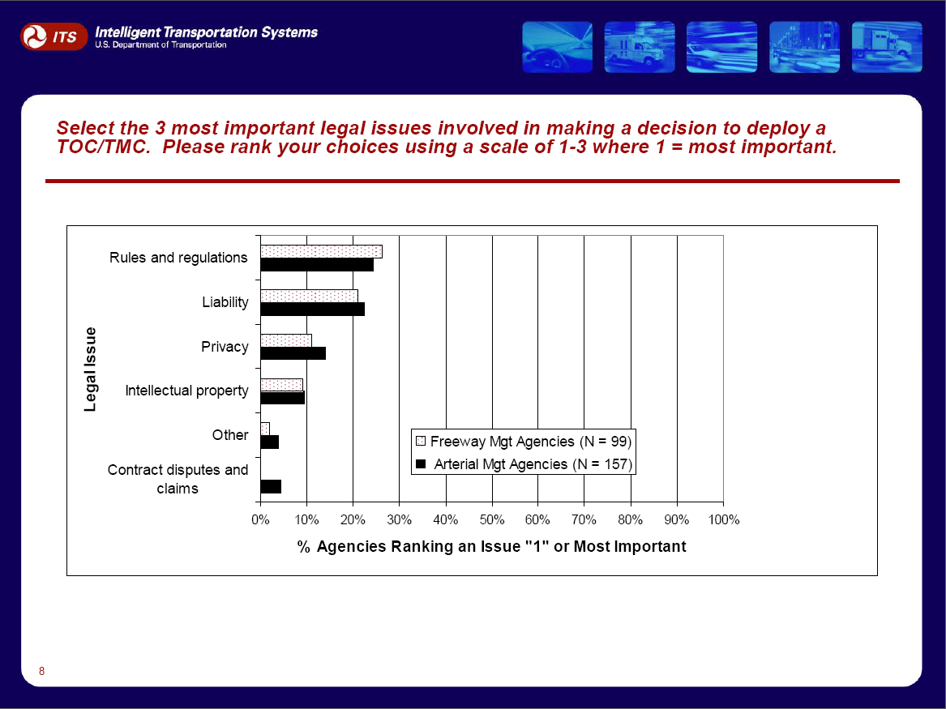

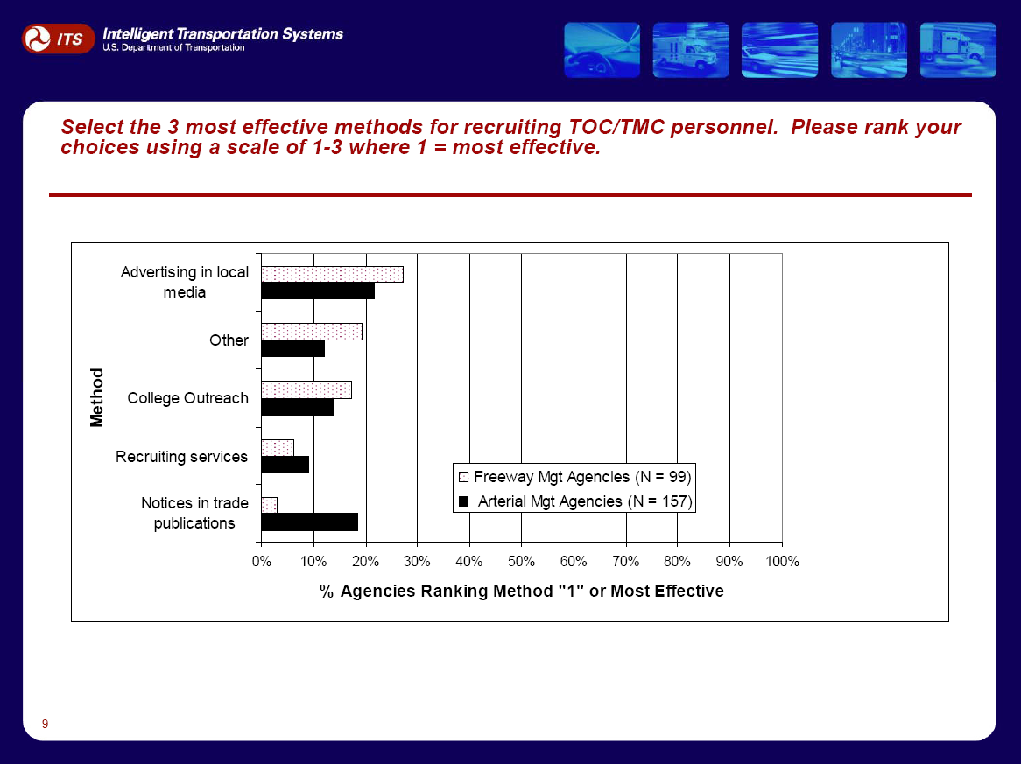

ITS Benefits, Costs, Deployment and Lessons Learned: 2008 Update

This report will be the next in a series of reports providing an inventory and synthesis of the latest information known about the benefits, costs, lessons, and deployment of ITS. Information in the report is drawn from the ITS Knowledge Resources. The report presents findings according to program areas within the intelligent infrastructure and intelligent vehicle applications, as well as the lesson categories from the ITS Lessons Learned Knowledge Resource, a repository of experience on how to plan, design, deploy, operate, and maintain ITS. The report has generally been published every two years, and the latest version is titled Intelligent Transportation Systems Benefits, Costs, and Lessons Learned: 2005 Update (FHWA-JPO-05-002). View an online version of the 2005 Update Report at this link:
http://www.itsdocs.fhwa.dot.gov/JPODOCS/REPTS_TE/14073.htm

Outcomes: In early 2008, the release of the BCDALL report discussing the benefits, costs, deployment and lessons learned for ITS. This edition will be the first to include deployment statistics and trend information, as well as a heightened focus on presentation of summary and synthesis information within each of the broad ITS application areas.

Development of Summary Information on Benefits, Costs, Deployment, and Lessons Learned

This activity represents a series of parallel activities to develop synthesized information on the Benefits, Costs, Deployment, and Lessons Learned regarding particular ITS applications (as represented in the taxonomy of ITS applications used in the Knowledge Resources) and particular aspects of ITS deployment (as represented by the major categories of lessons in the ITS Lessons Learned Knowledge Resource.

Summary Benefits - Synthesize ITS benefits and disbenefits documented in collected evaluations of a particular ITS application. Summary Benefits will provide a short overview of the prominent benefits (or disbenefits) of an ITS application, providing ranges when available for relevant performance measures, or representative examples in other cases.
Specific activities: Scan literature for recent publications regarding each ITS application area; review existing Benefits DB entries for each ITS application area alongside new findings, identify common benefits identified, metrics used, trends or themes; develop qualitative summary statements of benefit, and, where possible, list the range of reported results for a given metric
Deliverables: Summary benefit statements (1 to 2 paragraphs, max.) for one or more prominent ITS applications within each of the 16 major application areas to be covered in the next BCDALL Update report.
Outcomes: The release, via the Benefits Database Web site and future revisions of the Applications Overview Web site, of synthesis information regarding the benefits (and disbenefits) or particular ITS applications. This information will also be featured in the 2008 BCDALL Update report.
Summary Costs - Synthesize ITS costs (system costs or unit costs) based on multiple sources or data points for a particular ITS application or equipment package. Summary Costs will provide a short overview of the recurring and non-recurring costs, providing ranges when available or representative examples in other cases. An example of a synthesized system cost summary is a cost range for signal retiming per intersection based on six unique sources (see: www.itscosts.its.dot.gov/its/benecost.nsf/0/28A2F8923ACE84468525725F007B88EE).
Specific activities: as data become available, develop synthesized summary costs (see above for example); incorporate into restructured ITS core elements and other parts of the costs KR. Unit cost ranges are synthesized costs; hence, just as we have maintained these ranges, the same will need to be done for new synthesized costs.
Deliverables: roughly 12-15 new summary costs per year
Outcomes: refinement of existing resources, addition of new content, response to user needs.
Summary Deployment Facts - Summarized data describing the level of Intelligent Transportation System deployment. Deployment summaries can be based on multiple views of the data: national, state, metropolitan area, or agency. The purpose for collecting and disseminating summary deployment facts is to provide easily accessible information describing the state of deployment. These data can assist target audience members in making deployment decisions, DOT staff in managing ITS programs, and the general public in learning more about ITS. These summaries can also be used in combination with detailed deployment data describing the state of deployment of peer agencies to assist target audience decision-making.

Specific Activities: Deployment facts will be compiled from available secondary data sources, as well as any new primary data collection activities. Summary statistics will be derived from these data sources that portray the level of Intelligent Transportation System (ITS) deployment (e.g., % miles covered by surveillance, number of transit buses equipped with Automated Vehicle Location, etc..) at various levels of geography (e.g, nation, state, sub-state, metropolitan area). Historical trend data will be developed as appropriate and based on data availability. Where appropriate, an additional level of summarization will be developed, relating key deployment statistics to other factors, such as city or agency size, congestion level, or deployment trends.
Outcome: Improved accessibility of deployment data to the target audience. Improved ability to track trends and analyze deployment data. Improved impact of deployment data by making it possible for target audience members to compare local deployment information to national averages.

Summary Lessons Learned - Synthesize lessons learned experiences of ITS stakeholders in each of the nine lesson categories and present the results as a snapshot of major insights. These snapshots will be short and concise, providing well-summarized information on each lesson category or on any other topic of high importance.
Specific activities: Start with the major lesson categories and review existing lessons under each category (e.g., Leadership and Partnerships, Procurement, Funding, etc.). Gather additional information as needed. Write summary articles and post on the LLKR Web site.
Deliverables: Summary articles for nine lesson categories. Such summaries could also be included in the BCDALL report.
Outcomes: Major insights on each of the nine lesson categories.

Leaflet – Congestion Pricing

This is a follow-on activity, mirroring the successful series of publications released in January 2007 documenting the benefits, costs, lessons, and deployment of ITS applications for Traffic Incident Management, Traveler Information, Work Zones, and Traffic Signal Control. These documents can be downloaded at the links below:

- Traffic Incident Management: http://www.itsdocs.fhwa.dot.gov/JPODOCS/BROCHURE/14288.htm
- Traveler Information:
http://www.itsdocs.fhwa.dot.gov/JPODOCS/BROCHURE/14319.htm
- Work Zones:
http://www.itsdocs.fhwa.dot.gov/JPODOCS/BROCHURE/14320.htm
- Traffic Signal Control:
http://www.itsdocs.fhwa.dot.gov/JPODOCS/BROCHURE/14321.htm

The proposed document is a four-page leaflet (8.5 X 17” bi-fold) developed with the intent of presenting the latest information we know about the benefits, costs, lessons, and deployment in the area of Congestion Pricing. The intent is to link this leaflet to the Secretary’s Congestion Initiative and reach a wider target audience.

Specific Activities: Conduct a thorough literature review on congestion pricing including any existing benefits, costs, lessons learned currently in the database. Identify specific literature, major themes, messages, and topics to be included in the leaflet. Follow up with literature authors and other contacts for the latest information on Congestion Pricing (this may include interviews for gathering lessons learned.) Populate the Benefits, Costs, and Lessons Learned Knowledge Resource databases with leaflet content. Develop and execute an outreach strategy. Distribute leaflets as directed.

Outcomes:
- Reach a wider target audience and increase the awareness of Congestion Pricing.
- Depict benefits, costs and lessons learned to date on Congestion Pricing in a concise format.
- Raise the awareness of USDOT and other resources available on Congestion Pricing.

Web-based Inventory of Relevant Forms and Documents

The goal of this activity will be to develop a web-based inventory of useful and relevant forms and documents for use by agencies involved with deployment of ITS technology. The inventory will provide assistance in a variety of areas, ranging from planning and procuring ITS applications to designing, building, and operating such systems. The scope of these documents will include:
- Procurement
- Legal issues
- Planning
- Technical and institutional integration
Specific examples include: a Concept of Operations for a freeway management system, a sample RFP for an AVL system for a transit operating agency, or sample language regarding intellectual property rights.

Specific Activities:

- Gather requirements for forms and documents from target audience members through the PAUSE, review of listservs such as the Ops Exchange, and input from DOT staff.
- Collect documents. This may be accomplished through the use of the state of the practice survey, in which questions could be added about whether an agency has a useful document and would be willing to share it with the broader transportation community. Other means of gathering these documents include review of listservs that support the sharing of documents, literature searches, contacts with state and local agencies involved with ITS deployment, and other active search actions.
- Develop a database and web interface for the inventory.
- Maintain the inventory, adding documents as they become available.

Challenges/Barriers: One issue likely to emerge is concern on the part of providers of documents with open access. Limiting access to the inventory through password protection may be required.

Outcomes:
- Improved execution of deployment decisions by target audience members.
- Reduction of the perception of risk associated with ITS deployment on the part of target audience members.

Training

Develop and give training courses based on ITS Program Assessment activities and knowledge resources. Build on the highly successful “Talking Technology and Transportation” (T3) web seminar on decision-makers resources to offer this course in additional venues. Using the T3 course on the findings of the Puget Sound coordinated regional fare payment evaluation as a model, develop and give training courses based on the findings of additional evaluations. Training can be either in-person, entirely online, or an instructor-led Web cast.

Specific activities: T3 sessions - annual T3 offering of the BCDALL Knowledge Resources (new features); as needed, special topic T3s that show relevance to the Knowledge Resources (like Puget Sound, ITS Safety); highlight Benefits, Costs, and Lessons Learned in other T3 sessions where applicable. Seek training opportunities at conferences (AASHTO, ITE) and ITS State Chapter meetings. Consider other Web cast such as those sponsored by ITE (there are costs associated with these) and NTOC (free).
Deliverables: Deliverables include presentations for T3s, conferences, and workshops. Presentations/tutorials that can be downloaded for self-paced training. Include links to T3 and other training materials from the ITS Knowledge Resources.

Outcomes: These training courses would have the following benefits and outcomes.
- Increase awareness and knowledge of the Knowledge Resources.
- Keep users informed of new features and functionality of the Knowledge Resources.
- Help users to more effectively use the Knowledge Resources to support them in their ITS decision making processes.

